Smartphone - Mobile phone running a mobile operating system with advanced computing capability and connectivity

Computing and communications used to be distinct. With the introduction of mobile computing/communications, the two fields started to converge.

**Aspects of Mobile OS’**

User-facing software platform - Interface with display. RISC (Reduced Instruction Set Computing) type instructions

Real-Time Operating System - Operates sound IO, radio communications, error control.

**Smartphone anatomy**

Memory

Touch Screen

Radio comms interface

Antenna

Battery

Techniques to implement normal phone/tablet functionality (Speech, storage, image capturing, GPS etc)

Money Exchange - mobile replaces credit card. **Future** advancement.

Analogue signals - Sine Wave

Has an amplitude

Has a frequency

Has a phase

Sound - variation in air pressure

Microphones produce a continuous voltage proportional to the variation in air pressure.

**Discrete Time Signal**

Exists only at discrete points in time. Obtained by sampling a signal at a certain point in time. Measure the value at points between fixed time quanta.

**Python + Numpy, Scipy**

ADC/DAC Units - Analogue/Digital to Digital/Analogue Conversion units

Mobile phones do a lot of real time processing on signals obtained from the ADC

Also generate a lot of real time output for DAC

**Signals are buffered** for processing

Numpy - A library for Python used to deal with arrays and provide other useful functions for handling signals. Numpy also allows for floating point operations

SciPy - Python-based ecosystem of open-source software for mathematics, science, and engineering.

**Resampling**

Changes sampling rate by a factor, P

***yr = resample(y, (y.size) * P)***

decimation (reduction) if P < 1

up-sampling if P > 1

Filtering is carried out by this function

**Storing Signals in Files**

Sound files stored in .wav format

Information compactly represented in direct binary form

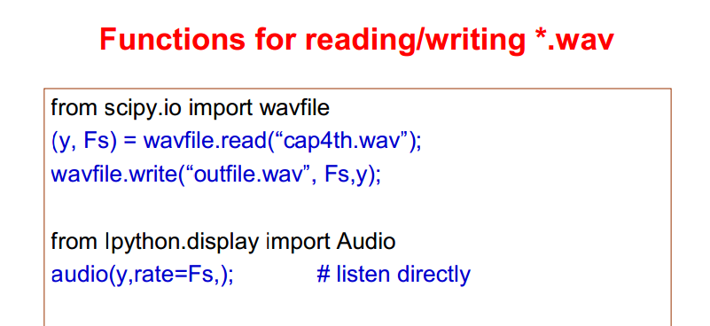

**Frequency spectrum and sampling**

Natural sounds are not pure sine waves, they are the composition of lots of sine waves.

Any type of signal has a frequency spectrum

Humans can detect signals within the frequency spectrum 50-20,00Hz, but most energy in speech is within 300-3400Hz

**Sampling Theorem**

If a signal’s frequency spectrum peaks at B Hz, and is sampled at >2B Hz, then the sounds can be reconstructed exactly with no loss. However, we can still only observe frequencies <=B Hz.

**Aliasing**

Aliasing is what happens when you sample a signal at less than double its frequency spectrum, producing a form of distortion.

I believe that for a sampling frequency Fs, any frequency F>Fs will produce an output frequency of |Fs - F|